Delivering 10 Gb/s in an Underwater Optical Wireless Communication System.

Malaya Dhari Singh
ECE Dept
Sir MVIT
Bengaluru, India
dharimalaya@gmail.com
Arpita S.Bhat
ECE Dept
Sir MVIT
Bengaluru, India
arpitabhat555@gmail.com
Preetish Bijla
ECE Dept
Sir MVIT
Bengaluru, India
Bijla14preetish@gmail.com
Vijayashri V.Belgaonkar
ECE Dept
Sir MVIT
Bengaluru, India
vijayashree_ec@sirmvit.edu
Suryansh Vaish
ECE Dept
Sir MVIT
Bengaluru, India
suryanshvaish615@gmail.com

Abstract— This paper is a design and simulation of an underwater optical wireless communication (UOWC) system. A 1550 nm laser diode (LD) is employed for 10 Gbit/s modulation using different schemes. The system incorporates Non-return-to-zero on-off (NRZ-OOK) models. The optical signal is transmitted through underwater environments like pure sea (PU). APD and PIN photodiodes are used for signal detection, with NRZ-OOK modulation and the APD photodiode providing the best performance. Results indicate that a transmission distance of 28 m was achieved in PU with a Q-factor of 5.4 dB and a bit error ratio (BER) of 10–9. This paper uses Optisystem v.21.

Keywords : Underwater Optical Wireless Communication (UOWC)-Modulation Schemes-Q-Factor
I. Introduction
Recently, underwater wireless communications as a promising technology has diverse applications across a wide range of environments, from within populations to local populations. Typically, human activity occurs in the underwater environment [1][2]. The sea covers over 70% of the Earth's surface, driving the need for underwater research and resource exploitation. Underwater Optical Wireless Communication (UOWC) offers high-speed, wide bandwidth data transmission with low latency, though it requires precise line-of-sight (LoS) and can be affected by water clarity. Technologies like lasers and LEDs are used for UOWC, offering varying ranges and speeds. Research has achieved data rates up to 25 Gbps, with advancements using NRZ-OOK. Performance is evaluated through factors like eye diagrams, BER, and Q factor across different water conditions.

II. Experiment Details
Our system incorporates essential components: The circuit includes a Pseudo-Random Bit Sequence Generator, NRZ Pulse Generator, CW Laser, MZ Modulator, Erbium-Doped Fiber Amplifier (EDFA), Line-of-Sight (LoS) Underwater Channel, Optical Amplifier, PIN Photodiode, Low Pass Gaussian Filter. The 3R regenerator ensures signal integrity, and the BER Analyzer predicts system effectiveness based on parameters like BER and Q-factor.

III. Theoretical background under woc systems
In water, the overall reduction of an optical signal depends on the extinction coefficient (c(\λ)), which is the combined effect of (a(\λ)) and (b(\λ)). [3]
c(λ) = a(λ)+b(λ) (1)
After traveling through the optical channel, the signal arrives at the receiving device, which includes the +detector PIN-PD. The term $P_{r}$represents the received power.

$P_{r}{=P}_{t}n_{t}n_{R}e\left[-c\left(λ\right)d\frac{d}{\left[cos\left(θ\right)\right]}\right]\frac{A_{Rec}cos\left(θ\right)}{2πd^{2}\left[1-cos\left(θ_{0}\right)\right]}$ (2)

In the context of optical communication, the overall attenuation of a signal in water depends on several factors. These include the average transmitter optical power ($P_{t}$), the transmitter’s optical efficiency ($n_{t}$), the receiver’s optical efficiency ($n_{R}$), the perpendicular distance (d) between the transmitter and receiver planes, the receiver’s aperture area (($A_{Rec}$), the angle ($θ$) between the perpendicular to the receiver plane and the line connecting the transmitter and receiver, and the laser beam divergence angle ($θ_{0}$)
The signal-to-noise ratio associated with a PIN photodiode [4]is described by
$SNR= \frac{M^{2}t_{P}^{2}}{2qB\left(I_{p}+I_{d}\right)M^{x+2}+\frac{4kTBF_{B}}{R_{L}}}$ (3)

In optical communication, the Q-factor is employed to assess link quality [5], is expressed by
$BER=\frac{1}{2}erfc\left(\frac{Q-factor}{2}\right)$ (4)

Ⅳ. SYSTEM DESIGN
A PRBS generator creates a test data stream, converted into NRZ pulse format. A 1550 nm CW laser serves as the optical carrier, modulated viaMach-Zehnder modulator. The signal passes through EDFAs and optical amplifiers, enters an underwater channel with attenuation and scattering, and is received by a PIN photodiode. Post-processing includes a Gaussian filter and 3R regenerator. The BER analyzer evaluates system performance underwater.
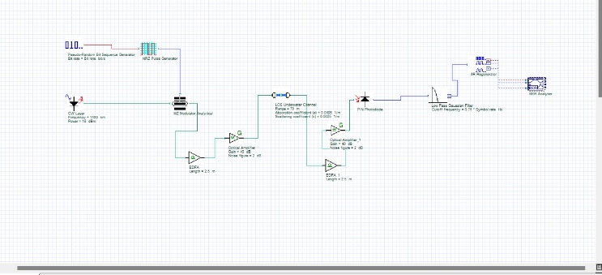

Ⅴ. Results and Discussions
We employed OptiSystem software to simulate the proposed underwater optical wireless communication (UOWC)[6)]system, operating at data rates of 10 Gb/s using NRZ modulation schemes. System performance evaluation involved analyzing critical parameters like eye-opening diagrams, Q-factor, and bit error rate (BER). These assessments were conducted under Pure Sea water conditions(PU).

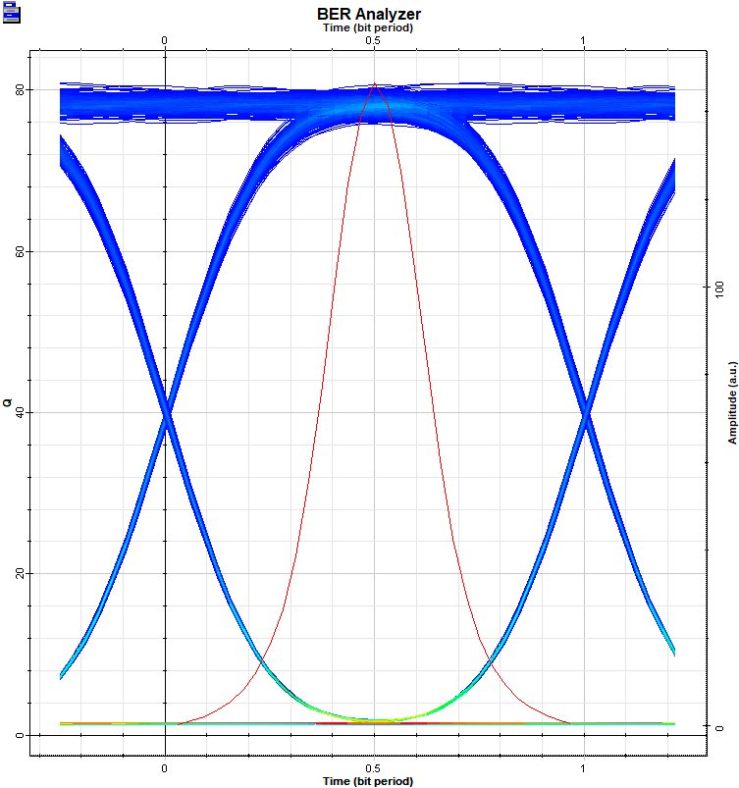
In this optical system, a 1550nm CW laser outputs at 18dBm. The setup includes a 2.5-meter EDFA, an Optical Amplifier with 40dB gain and 2dB Noise Figure, and a Loss Underwater Channel with a range of 70 meters.
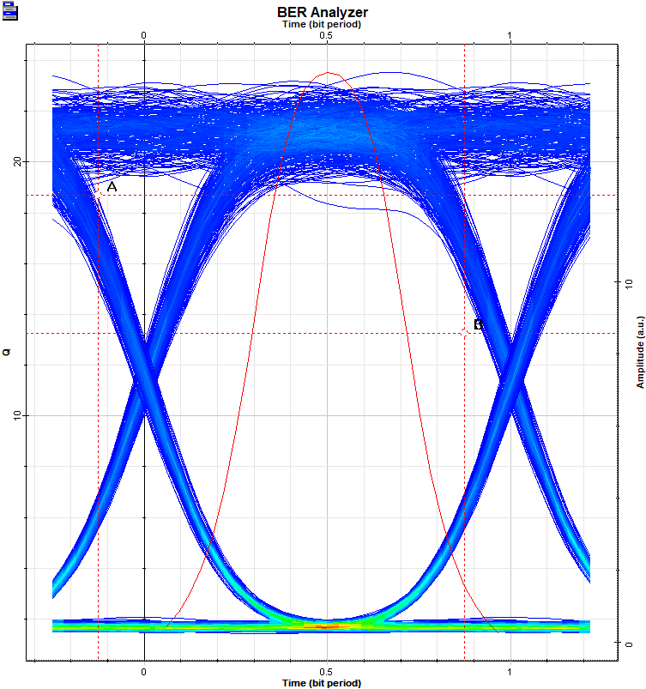
In this optical system, a 1550nm CW laser outputs at 10dBm. The setup includes a 2.5-meter EDFA, an Optical Amplifier with 40dB gain and 2dB Noise Figure, and a Loss Underwater Channel with a range of 100 meters.
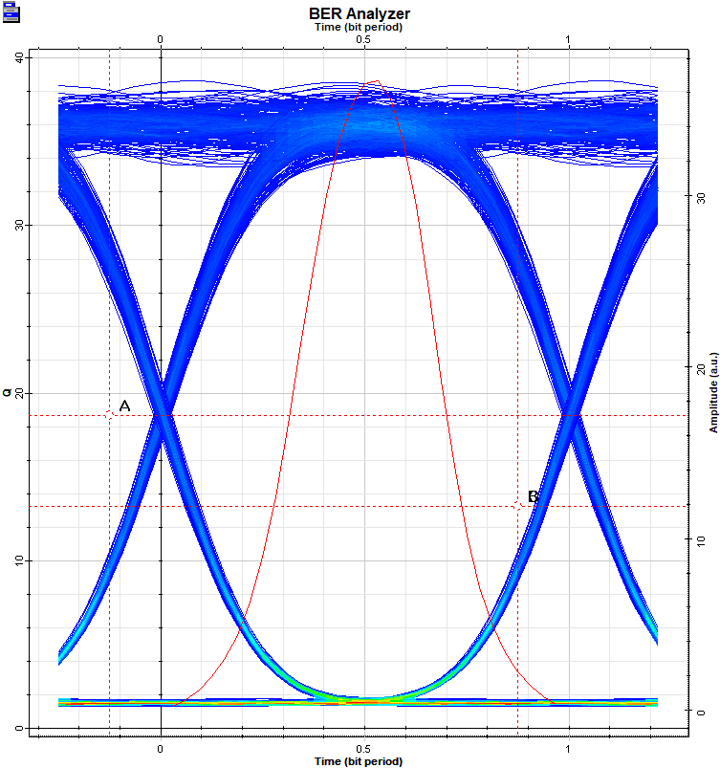
In this optical system, a 1550nm CW laser outputs at 12dBm. The setup includes a 2.5-meter EDFA, an Optical Amplifier with 40dB gain and 2dB Noise Figure, and a Loss Underwater Channel with a range of 90 meters.
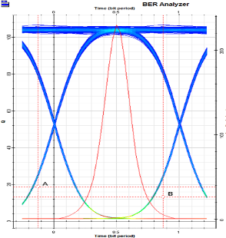
In this optical system, a 1550nm CW laser outputs at 20dBm. The setup includes a 2.5-meter EDFA, an Optical Amplifier with 40dB gain and 2dB Noise Figure, and a Loss Underwater Channel with a range of 60 meters.

VI. CONCLUSION
The paper demonstrates the feasibility of achieving 10 Gb/s data rates in underwater optical wireless communication. Environmental factors like water turbidity influence performance. The system shows potential for underwater applications, and future work is needed to enhance reliability in diverse conditions. Here we have used optical amplifier, PIN Photodiode where our gain is 40 db. By using LOS underwater channel where we achieved the range of 100 meters.
ACKNOWLEDGEMENT
The authors extend their thanks to the Research and Development Center within the Department of Electronics and Communication Engineering at Sir M. Visvesvaraya Institute of Technology, Bengaluru, for granting access to their research laboratory facilities.
REFERENCES.
1. J.V. Aravind, S. Kumar, S. Prince, Performance Analysis of UWOC using SISO and SIMO Techniques. J. Phys. Conf. Ser. 6, 2021 (1964). https://doi.org/10.1088/1742-6596/1964/6/062025.
2. P. Wang, C. Li, B. Wang, and Z. Xu, “Real-Time 25Mb/s Data Transmission for Underwater Optical Wireless Communication Using a Commercial Blue LED and APD Detection,” in Asia Communications and Photonics Conference 2016, Optical Society of America, AS2C-3 (2016). https:// doi.org/ 10. 1364/ACPC.2016.AS2C.3.
3. C. Gabriel, M. -A. Khalighi, S. Bourennane, P. Leon, V. Rigaud, Channel modeling for underwater optical communication. IEEE GLOBECOM Workshops (GC Wkshps, Houston, 2011), pp. 833–811. https:// doi.org/10.1109/GLOCOMW.2011.6162571 . S.Arnon, Underwater optical wireless communication network, 49(1), 2010. https://doi.org/10.1117/1.3280288.
4. M. B. Al-Deen, M. A. A. Ali, and Z. A. Saleh, Improving the optical link for UVLC using MIMO technique, J. Opt. Commun., 3, 2021. https://doi.org/10.1515/joc-2021-0050.
5. M. Kasmi, H. Mrabet, S. Mhatli, F. Bahloul, I. Dayoub, K. Oh, Performance enhancement of 64 Gb/s OFDM system at 1550 nm over multimode fiber using Volterra equalization. Opt. Commun. 449, 86–93 (2019) .
6. C.Y. Li, H.H. Lu, W.S. Tsai, Z.H. Wang, C.W. Hung, C.W. Su, Y.F. Lu, A 5 m/25 Gbps underwater wireless optical communication system. IEEE Phot. J. 10(3), 1–9 (2018). https:// doi.org/ 10. 1109/JPHOT.2018.2842762

